Blue Carbon / Carbon Dynamics in an EWN Context

Background
Carbon (C) cycling provides the foundation for all ecological functions in both natural and engineered systems (including wetlands), and C dynamics are of increasing interest globally. While studies have shown that C characteristics and fate differ between natural and built environments, few studies quantify C accumulation and quality in created or restored environments. In particular, studies have not evaluated mineral-complexed carbon in wetlands despite that this carbon pool represents a mechanism to store stabilized carbon for very long periods. Evaluating C dynamics improves our capacity to design and build better projects under EWN and to document their benefits with regard to carbon. Additionally, because the Department of Defense (DoD) manages large tracts of land containing wetlands, integrating carbon studies into the research portfolio will improve our ability to manage these lands.

Objectives
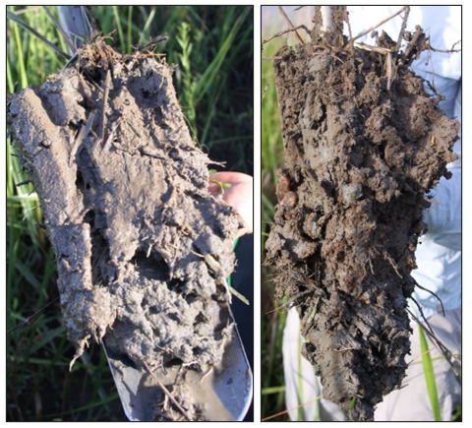
No studies of C dynamics have specifically been integrated with the EWN Initiative framework. We will address this data gap to increase our capacity to design and manage EWN projects for maximal C-cycling benefits. Because dredged materials contain a higher abundance of mineral sediments than most coastal zone soils, EWN features created using dredged materials may represent ideal locations for carbon mineralization and long-term sequestration. Demonstrating this will assist in justifying future EWN initiatives within a C dynamics context and will support further integration of carbon accounting across DoD projects and installations.

Approach
We will sample triplicate wetland soil cores from eight sites (four restored or created wetlands and four unaltered reference areas). Sample locations will include areas in Florida, Mobile Bay, Chesapeake Bay, and the Great Lakes. We will use novel carbon fractionation, aggregation, and characterization techniques to investigate stable, mineralized carbon storage. This will include a new acid-washing approach that has never been applied to wetland systems.

Outcomes
Results of the study can be used to (1) determine the “value” of carbon storage in EWN projects and (2) inform the design of future projects to optimize long-term carbon storage. This project will help to quantify the environmental, economic, and social benefits of incorporating carbon dynamics into EWN.
Soil samples from marshes constructed with dredged materials (left) differ from natural marshes (right), especially with regards to carbon content and carbon characteristics as seen by the darker color associated with the unaltered marsh.

