Identifying Best Practices for Financing Natural Infrastructure Projects: Insights for the Engineering with Nature® Initiative

Background

There is growing interest and a proportional increase in the application of natural infrastructure (NI) to achieve greater resilience among communities susceptible to flood and storm risk, sea level rise, and other types of natural hazards. While our collective understanding of NI utility and function continues to expand through a growing body of scientific literature, case studies, and general increase in deployment of NI projects, there is currently less information available to practitioners on how to fund or finance them. As NI continues to be mainstreamed by USACE Civil Works and by non-federal entities, project leads will require innovative finacing practices to account for the different lifecycle costs associated with NI projects.

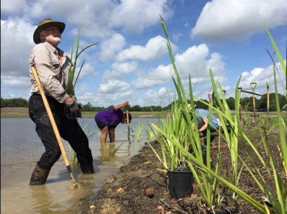
Objectives

This project seeks to identify, evaluate, and share examples of NI projects that have secured the necessary funds from a variety of sources and innovating methods. In particular, this project is exploring the manner in which funds have been secured for scoping, designing, constructing, monitoring, and/or adaptively managing NI projects. Documenting transferable lessons from innovative NI financing cases for USACE and practitionner audiences will support the successful implementation and management of NI projects and for evolving the NI planning process.
Wetland planting for Exploration Green, a Natural Infrastructure project in Clear Lake City, Texas.

Approach
The project is being executed collaboratively with researchers from the Institute of Water Resources that are involved in the Systems Approach to Geomorphic Engineering community of practice. The effort is using a case study approach to showcase insights from a diversity of applicable NI projects. Project leads start by identify individuals affiliated with the projects that will serve as POCs for project-specific information and/or co-authors of technical notes, which feature their respective project(s). Through semi-structured interviews with POCs, pertinent information about NI projects is collected and synthesized. Analysis of common themes, best approaches to financing, enabling factors, issues/challenges, and lingering knowledge gaps associated with NI projects are derived. A peer review team of NI experts is convened to elicit feedback on the usefulness of case studies for practitioners and nominations for additional NI projects to feature.

Outcomes
This project will fill key knowledge gaps surrounding best practices and lessons learned for financing NI proejcts, which, to date, are scarcely available. Results from this work will be compiled into a series of technical notes (one technical note per project), which will be made available to the public through a number of USACE-based and collaborator websites. Additionally, this work will directly support the Engineering with Nature® Initiatve, through which the social (e.g., health and well-being), economic (e.g., avoided damages), and environmental (e.g., restoration) benefits of NI are being scaled for communities across the nation.

