Addressing Equity and Identifying Bias in Engineering With Nature® Project Decision-Making and Incorporating Wellbeing Benefits of Nature
Background

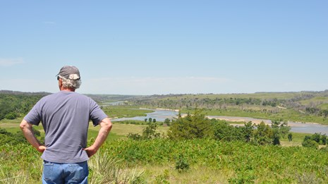
Executive Order (EO) 140008 directs federal agencies to incorporate environmental justice into their missions by developing programs, policies, and activities that address the disproportionately high and adverse human health, environmental, climate-related, and other cumulative impacts on disadvantaged communities. Addressing the disproportionate outcomes highlighted in the EO needs to start by interrogating potential underlying causes that formally and informally exist in the initiation and promotion of USACE projects and activities. Intuitively, there are sources of bias in the definition and inclusion of project costs and benefits that would yield unequal access to Civil Works, including Engineering With Nature (EWN) benefits.

Objective

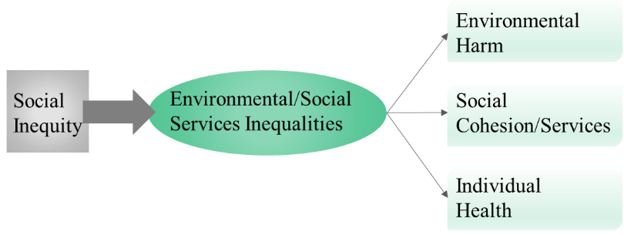
The objective of this project is to improve USACE’s ability to incorporate equity concerns and wellbeing benefits into the planning process and analysis. Identify potential sources of inequity and bias in decision-making throughout USACE’s planning and operations processes, with a particular emphasis on projects that incorporate EWN principles, is a critical step in enabling decision-makers to understand patterns in USACE investment. Ultimately, this will result in processes that can better and more equitably serve the Nation. Additionally, investigating how to incorporate the benefits of nature for human wellbeing will help USACE conduct more comprehensive benefits accounting.

Approach
The technical approach will be informed by mixed-methods approaches common within environmental justice research. The methodology developed will be used to identify the determinants of bias in USACE project planning processes through geographically weighted regression analysis. Semi-structured interviews with USACE personnel and content analysis of USACE planning documents will complement quantitiative analyses and allow project leads to further explore opportunities for project selection bias and inequity that arise in the USACE project planning process. A three-dimensional conceptualization of equity (distributional, recognitional, and procedural) will be adopted to understand current state of practice and to find opportunities for improved alignment.

Outcomes
This project will advance the consideration of equity by USACE districts by highlighting rules and norms that can propagate inequities. Identifying inequities and biases in EWN projects and developing benefit metrics for access to natural and nature-based features will increase the transition of technology from research and development into practice.

