NIOT Case Study Development, User-Base Expansion and Updates

Background

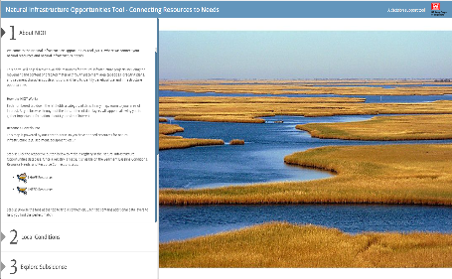
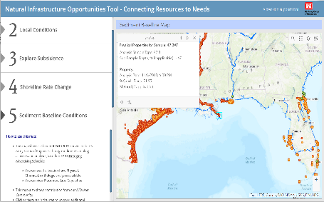
The Natural Infrastructure Opportunities Tool (NIOT), a webviewer facilitating more informed and efficient decisions making for Natural Infrastructure (NI) projects, was a first step in providing a platform for brainstorming NII opportunities, aggregating data and tools, and making connections between stakeholders with resources and stakeholders in need of resources. The current project aims to transition the tool so that it is even more comprehensive, with a focus on developing a series of case studies highlighting the viewer’s utility.

Objectives

With the goal of highlighting case studies and providing synergistic natural infrastructure project opportunities with USACE and other private entities like Caterpillar Corporation, TNC, state agencies, etc., the objectives of this project are to demonstrate how the tool will allow for collaborative, cost saving opportunities for beneficial use of dredged material, and other natural infrastructure, Engineering With Nature, and Regional Sediment Management projects while increasing planning and operations efficiency Corps-wide. This project represents a step forward for NI planning and supports EWN, DOER and the USACE Navigation program’s investment in NNBF, NBS and NII.
Figure 1. The NIOT webviewer allows users to explore data relevant to NI projects in a geospatial platform.

Approach

The proposed approach includes developing a series of coastal and inland case studies showing the utility of the viewer. In the course of case study development, newly identified data sets will be added to the viewer. In addition to case study development, the NIOT will be updated using feedback from virtual or in person workshops designed to obtain user feedback from different stakeholder groups and stakeholders with different objectives. We plan to continue to develop a user base by advertising the viewer’s capabilities at conferences and workshops as well as written case study documentation.

Outcomes
Updating the NIOT viewer and deliberately highlighting how it can be used to plan and implement and natural infrastructure projects as well as optimize beneficial use, will benefit the USACE, resource agencies, private and public stakeholders. Examples that encourage creative use of the viewer will ultimately lead to improved natural infrastructure projects that benefit the environment, economy, and the public.

