Reservoir Sedimentation and Sustainability with NNBF

Background
USACE is the leading Federal agency providing public recreational facilities and reservoirs are one of the major providers for this public usage. Shoreline erosion is a major issue within reservoirs and there are no existing guidelines available to establish priorities to treat excessive shoreline erosion. Siltation is negatively affecting lake storage capacity, water quality, recreational activities, and fisheries within the lake. Like many of the reservoirs in the USACE portfolio, large expanses of open water, heavy recreational boating activity, dramatic annual water level fluctuations, differing geologic materials, prevailing wind and resulting waves and other geomorphic weathering agents provide perfect conditions for excessive shoreline erosion. The dynamic nature of Nolin’s shoreline environment inhibits the establishment of native aquatic vegetation and prevents terrestrial vegetation from succeeding at a rate fast enough to stabilize the banks. Therefore, much of the lake shoreline is experiencing in many cases excessive erosion. The erosion leads to infilling of the reservoir pool-decreasing reservoir capacity, added sediment downstream-choking channels, and additional sediment which is an impediment for navigation Ohio River channel-increased dredging. LRL recently constructed an EWN focused pilot study using limited riprap as stone toe protection adjacent to the shoreline to provide erosion protection but also environmental habitat in the shallow waters behind the revetment. The District is currently investigating usage of “reef balls” as a new form of stabilization that may further enhance the EWN-NNBF applications with even greater environmental benefits. These applications provide a basis for researching and applying new EWN-NNBF practices in the field. The District is also interested in developing a planning matrix tool to prioritize new EWN-NNBF applications in other parts of the reservoir.

Objectives
The Nolin River Dam reservoir has implemented EWN-NNBF in a recent bank protection project. This will be developed further and documented along with new applications adding vegetative measures and testing other measures such as woody-debris, locked-logs, reef ball reservoir erosion control projects to develop a shoreline stabilization plan implementing EWN-NNBF. Investigate and document human health interactions with nature and recreational opportunities as it relates to area usage at the reservoir. Work with the reservoir management staff to research the sociological EWN benefits.

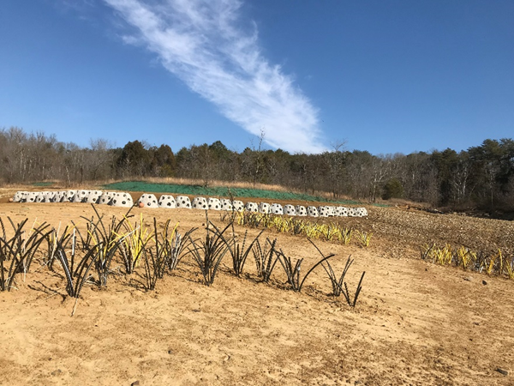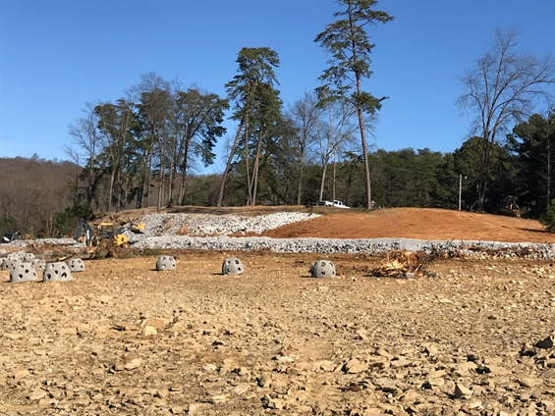
Figure 1. Nolin River Reservoir shoreline stabilization and restoration project with toe protection, reef balls, vegetative bank protection and plug plantings.

Approach
The project will develop, test and monitor NNBF projects to provide USACE and partners with the new and improved methods for stabilizing eroding shorelines. Special emphasis will be placed on incorporating in-situ material materials and enhancing toe protection designs with vegetative, woody and other natural components. In addition, high-resolution terrain data will be analyzed to determine shoreline stability trends which will assist in determining the type and location for future EWN practices.

Outcomes
This study will document appropriate shoreline erosion alternatives and applications using EWN-NNBF techniques. Additional products include determining appropriate NNBF applications and document human health interactions with nature and recreational opportunities as it relates to area usage at the reservoir. This study delivers a robust approach for assessing and documenting reservoir EWN applications that provides the greatest social, economic, and environmental engineering benefit.

