Post Wildfire Watershed Restoration for Flood Risk Management (FRM)

Background
The Las Conchas Wildfire burned over 156,000 acres and it is ranked as the second largest fire in New Mexico History. The Santa Clara Canyon sustained a near total burn, which drastically changed the environment and sediment stability of the canyon. After the event, a 1% chance rain event exhibited a 400% increase in peak flow conditions when compared to pre-fire conditions. This is due to the extreme loss of vegetation and subsequent soil instabilities that combine to make the region highly susceptible to debris flow events that endanger the Santa Clara Pueblo at the base of the canyon. Since 2011 the Santa Clara Pueblo Forestry Department in conjunction with the Albuquerque District, FEMA, NRCS, and several other partners have been working to reduce flood hazard in the Pueblo. Through the aid of five Presidential Disaster Declarations for both the fires and flood events, considerable effort has been directed to increasing stream capacity through the populated region of Santa Clara Creek via dredging and levee improvements. Over 26 million has been spent on debris removal from the creek channel and former pond sites. Three large multi-million-dollar gabion structures have been constructed between the Pueblo and upper canyon watershed to attenuate flood peaks and capture sediment. The Forestry Department has been mulching and contour felling dead stand to stabilize high elevation slopes. In addition, more than 4,000 log and boulder structures have been built in unraveling drainages above first order streams.

Objectives
Managing wildfire recovery efforts by applying EWN principles has the potential to provide a wide range of flood risk management benefits to rural and urban settings while increasing co-benefits for the entire watershed. Co-benefits include economic, social, archeological, cultural, aesthetic, recreational and biological functioning habitat enhancements. Additionally, the alteration or destruction of large expanses of natural areas reduces the qualtity of valuable aquatic and terrestrial habitat, reduced water quality, increased runoff events with increased flooding. The benefits of working on a wholistic scale are to shape a system of nested FRM projects throughout the watershed that will work in unison to provide the greatest benefits. To accomplish a wholistic watershed approach, the design of stabilization and restoration projects based on EWN principles needs to include reestablishing stream hydraulics, channel morphology, removal of invasive species, modified landuse practices and restoring riparian and aquatic zone habitat, (Figure 1). Experiences gained will be transferred to other areas within the Western US that experience wildfires and require FRM guidance on wildfire recovery methods.

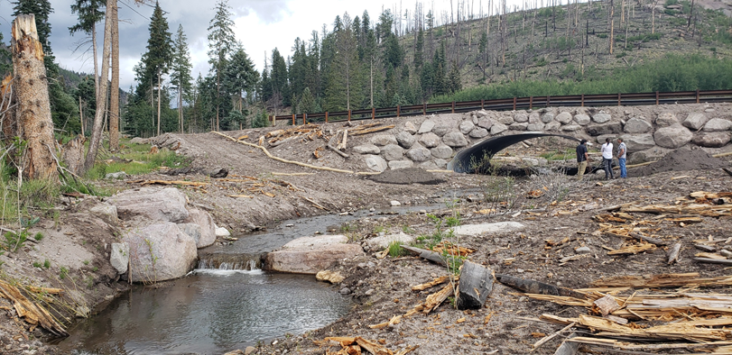
Figure 1. Santa Clara Creek stabilization and restoration project with grade control structures, vegetative bank protection and replantings, bottomless culvert design and fllodplain management practices.

Approach
The project will develop, test and monitor EWN wildfire FRM and erosion control projects to provide USACE and partners with the state-of-the-art science for future wildfire recovery efforts. Special emphasis will be placed on in-situ material usage for restoration and vegetation management alternatives. In addition a watershed stability tool-FluvialGeomorph will be used to assess the high-resolution terrain data available to determine channel and watershed stability trends which will assist in determining the type and location for EWN practices.

Outcomes
Documenting appropriate usage of EWN FRM alternatives, determining suitable usage of in-situ materials, and a watershed assessment analysis tool provides a well-based assessment platform in which to assist USACE partners for watershed wildfire recovery efforts. These initiatives deliver a robust approach for assessing and documenting EWN that provides the greatest social, economic, and environmental benefit.

