Promoting Sustainability of Sensitive SAV Habitats through Innovative Dredging and Placement Practices

Background
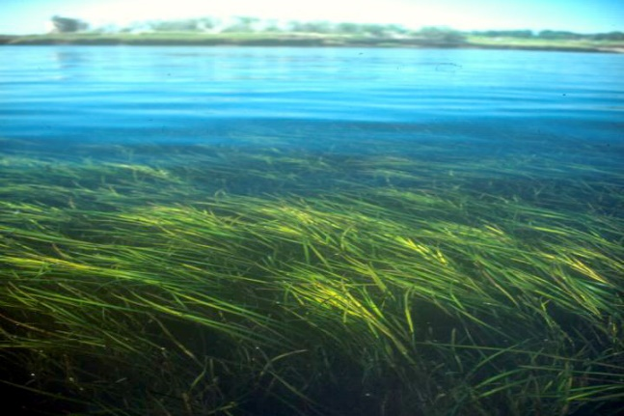
Submerged aquatic vegetation (SAV) habitats provide a variety of ecosystem services, including fish habitat, nutrient sequestration, and protection from currents and waves. However, they face multiple threats, such as poor water quality, coastal development, and climate change. Therefore, protecting and restoring these habitats is a high priority for resource agencies. Indeed, resource agencies have historically focused on the negative impacts of open-water sediment placement on SAV, impeding novel dredging applications in these habitats. Qualitative information and several independent observations, though, suggest that long-term placement of sediment-derived NNBF provides a protective benefit to SAV and subsequently has resulted in an increased area of coverage with increased density. Unfortunately, as these accounts and observations have not been well documented, they do not provide sufficient evidence to convince resource agencies of the benefitis associated with innovative dredging and placement practices.
Figure 1. Eelgrass meadow; photo credit: VIMS (https://www.vims.edu/about/at_a_glance/photo_galleries/sav/index.php)

Objectives
This project will evaluate historical, ongoing, and future innovative dredging and placement activities in various geographical locations to more fully distinguish between short-term, temporary impacts to SAV and long-term, temporal outcomes that potentially demonstrate positive benefits for sensitive habitats.
We aim to elucidate an approach that leverages dredged sediment to promote restored SAV habitat and associated environmental, social, and flood risk reduction benefits.

Approach
We will explore historical examples (non-field-based case studies) from U.S. Army Corps of Engineers (USACE) districts to address opportunistic SAV habitat development as a result of placement activities as well as SAV recovery on short time scales. Additionally, we will leverage collaborative field-scale projects that demonstrate proof of concept, such as those at Swan Island Restoration in Chesapeake Bay (Baltimore District) and beneficial use of Barnegat Inlet dredged sediments (Philadelphia District).

Outcomes
We plan to produce a position paper on threats to SAV habitat and how innovative dreding can help expand these habitats. Additionally, we will document observations, results, lessons learned, and best practices from the case studies and field demonstrations.
This research can help overturn the negative misconceptions associated with open-water sediment placement in SAV habitats. Furthermore, this work will enable USACE to accomplish its navigation mission quickly with less impedence while also enhancing, restoring, or maintaining SAV and other sensitive habitats in a manner consistent with EWN. Moreover, open-water placement is likely to save time and money for USACE Districts by decreasing the distance required for pumping and maintaining capacity of confined disposal facilities for more problematic sediments. Creating sustainable submerged wetland habitats adjacent to federal navigation channels can also more effectively sustain the channels over time, reducing dredging requirements.

